New_York_Flankees_solution_documentation
Written by: Yuval Quina
I began this challenge by scanning ports & services using Nmap:
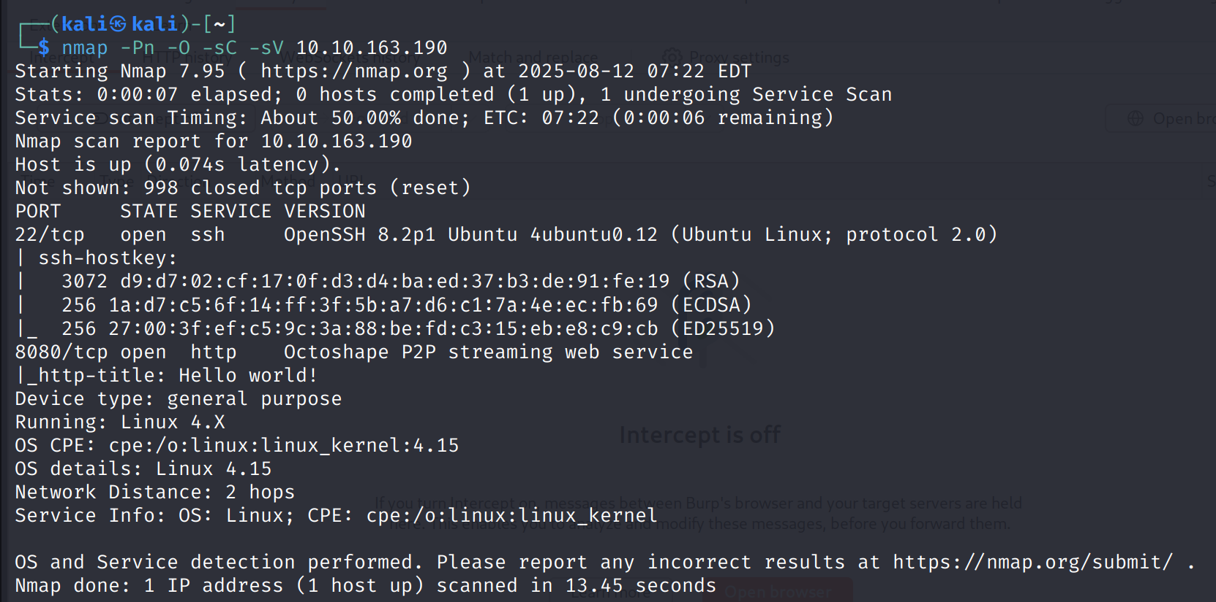
I noticed that it has an http service on port 8080 so I entered its website:
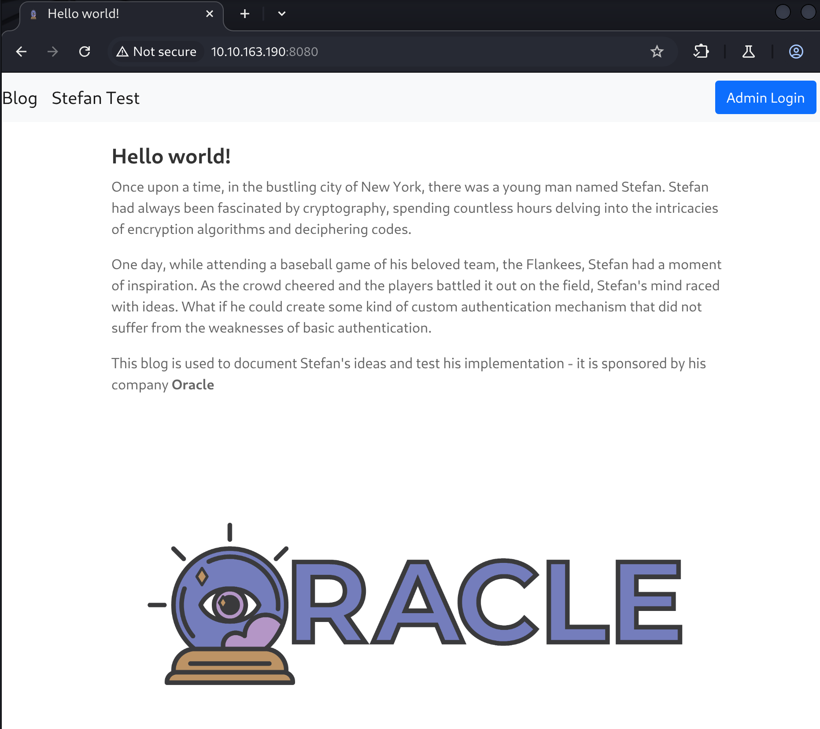
I noticed a “Admin Login” button on the top right corner so I clicked on it, and it led me to this login page:
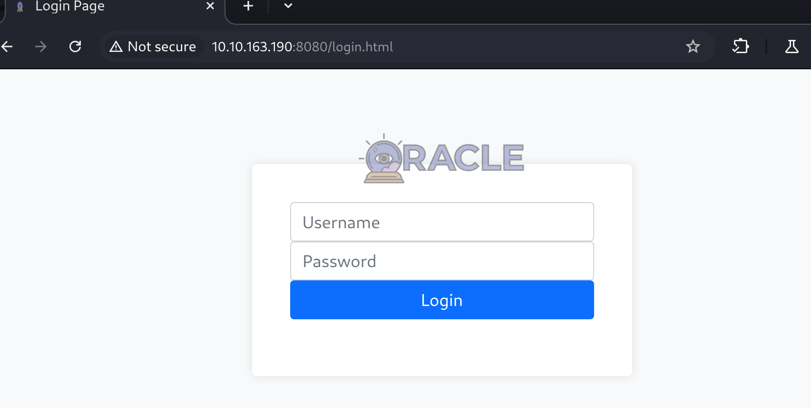
Now I returned to the first page, and I clicked on the “Stefan Test” which led me to this page:
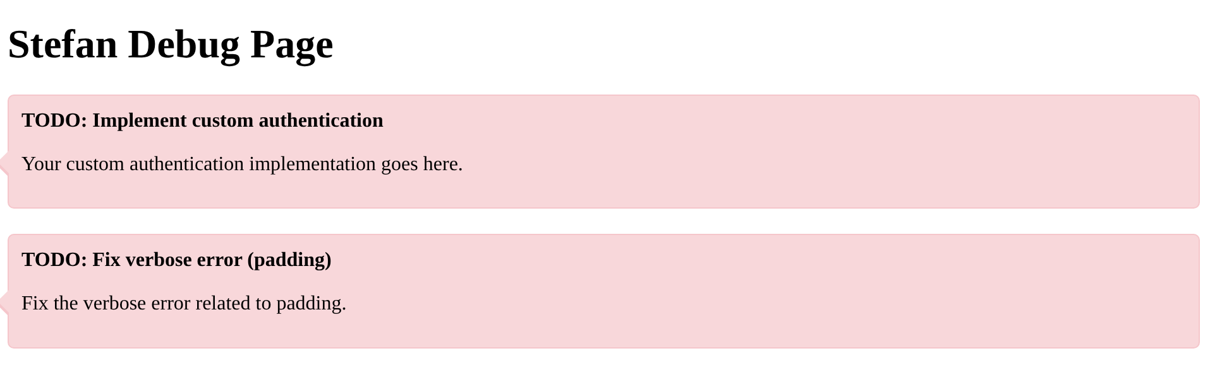
I looked at the inspector and found this JavaScript function:
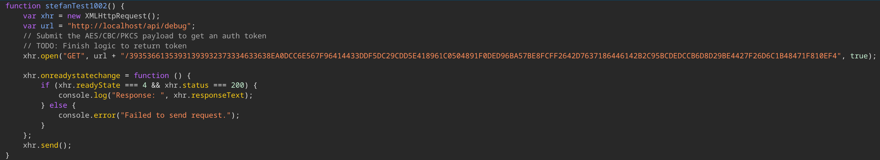
After reading it a bit I understood that

